NETWORK CABLE AND CONNECTOR

- Draw a labeled diagram of a Cat6 Ethernet cable, showing the color order of wires in the T568B standard and labeling the RJ-45 connector pins.
Answer
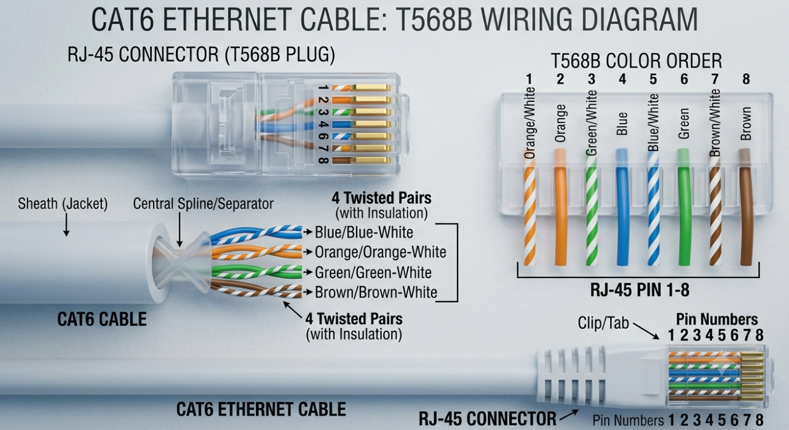

- List three types of network cables (such as Cat5e, Cat6, and fiber optic) and for each, mention one real-world app or device (like a Wi-Fi router, Zomato POS terminal, or IPL streaming server) where it would be used, explaining why.
Answer
1) Cat5e – Zomato (or similar) POS terminal in a restaurant
- Typical use: Connecting the POS terminal to the restaurant’s router/switch over a short run (usually under 30–50 m).
- Why Cat5e:
  - Supports 1 Gbps up to 100 m, which is more than enough for order entry, payment processing, and cloud sync.
  - Cheap, flexible, and widely available—ideal for high-volume deployments across many outlets.
  - Works well with Power over Ethernet (PoE) switches or injectors if the terminal or its network gear needs powered connectivity.
- In practice, a restaurant’s back-of-house network (POS, printer, maybe a small switch) is often built on Cat5e because it’s cost-effective and fully adequate for the bandwidth needs.
2) Cat6 – Gaming café PC connected to a gaming router/switch
- Typical use: Patch cable from each gaming PC to a central switch or gaming router in a gaming café or home gaming rig.
- Why Cat6:
  - Higher bandwidth (250 MHz) and better shielding than Cat5e, reducing crosstalk and interference in dense cable runs.
  - Supports 1 Gbps reliably at 100 m and 10 Gbps up to ~55 m, giving headroom for future upgrades (e.g., 10G LAN, heavy local file transfers, game server hosting).
  - More robust for environments with lots of devices, long sessions, and high throughput (game updates, LAN parties, streaming while gaming).
3) Fiber optic – IPL streaming server in a data center / CDN edge node
- Typical use: Uplinks between switches/routers inside a data center or from the data center to the ISP/CDN that delivers IPL live streams to millions of viewers.
- Why fiber:
  - Extremely high capacity (10/40/100 Gbps and beyond) over long distances with very low latency—critical for live sports streaming at scale.
  - Immune to electromagnetic interference, making it ideal for backbone links where reliability and throughput matter more than cost per meter.
  - Used for inter-rack, inter-building, and metro/long-haul links that carry aggregated traffic from many users and servers.

- Watch a YouTube video showing how to crimp an RJ-45 connector onto a network cable, then write down the step-by-step process in your own words and mention two common mistakes to avoid.
Answer
- Strip the outer jacket Using a wire stripper (often built into the crimping tool), remove about 1 to 1.5 inches of the outer cable sheath. Score it gently and twist rather than cutting deep, so you don't nick the wires inside.
- Untwist and separate the pairs Inside you'll find four twisted pairs: orange/white-orange, green/white-green, blue/white-blue, and brown/white-brown. Gently untwist each pair and pull the individual wires straight. If there's a plastic spline or core in the middle, cut it off.
- Arrange the wires in order Line the eight wires up side by side following a wiring standard, usually T568B: white-orange, orange, white-green, blue, white-blue, green, white-brown, brown, read left to right with the connector's clip facing down and away from you.
- Trim the wires flush Hold the wires against the connector to check the length, then cut them all in one straight line so they're even and just long enough to reach the front of the connector.
- Insert the wires into the connector Slide all eight wires into the RJ-45 connector at once, keeping them flat and in order. Push firmly until you can see each wire tip reach the very front of the connector, and make sure the outer jacket extends slightly into the connector body for strain relief.
- Crimp the connector Place the loaded connector into the crimping tool's jack and squeeze the handles firmly. This drives small metal contacts through each wire's insulation and locks the connector onto the cable jacket.
- Repeat and test Do the same process on the other end of the cable, then use a cable tester to check continuity on all eight pins. If any pin fails, cut the connector off and redo that end.

Two common mistakes worth watching for:
- Wires not reaching the front of the connector. If any wire stops short of the tip, the crimp contacts won't pierce it properly, giving you a flaky or dead connection on that pin. Always check by eye (or against a strong light) before crimping.
- Untwisting the pairs too far. Twisted pairs cancel out electrical interference — untwisting more than about half an inch back from the connector weakens that protection and can cause signal issues, especially on longer runs. Keep the twist intact right up until just before the wires enter the connector.

- Given the following scenario: You are setting up a gaming zone for an IPL screening event and need to connect multiple screens and consoles. Choose the appropriate cable and connector types for high-speed, reliable connections, and explain your choices.

Answer
For an IPL screening gaming zone with multiple screens and consoles, use HDMI 2.1 (Ultra High Speed) cables with standard HDMI Type-A connectors for every console-to-screen link, and Cat6 (or Cat6a) Ethernet cables with RJ-45 connectors for any networked AV, control, or internet needs.
Primary A/V connections: Console → Screen
Use:
- Cable: HDMI 2.1 “Ultra High Speed” certified cable (48 Gbps).
- Connector: HDMI Type-A (standard full-size HDMI) on both ends.
Why this choice:
- Current consoles (PS5, Xbox Series X/S) output only over HDMI and need HDMI 2.1 to run 4K at 120 Hz, VRR, and ALLM properly.
- HDMI 2.1’s 48 Gbps bandwidth supports 4K/120 Hz, HDR, and high-quality audio in one cable, which is ideal for big screens at an event.
- Using certified Ultra High Speed cables reduces risk of dropouts, black screens, or fallback to lower refresh rates under long runs or in noisy environments.
Practical tips for the event:
- Match cable length to run distance; for runs over ~5–7 m, buy good-quality, thicker-gauge HDMI 2.1 cables to maintain signal integrity.
- If you must go very long (10–15 m+), consider active HDMI 2.1 cables or an HDMI-over-fiber/extender solution, but still terminate with HDMI at the console and display.
Network / control / AV-over-IP (if used)
Use:
- Cable: Cat6 (or Cat6a for future-proofing and longer 10 Gb runs).
- Connector: RJ-45 (8P8C) on both ends, wired to T568B.
Why this choice:
- Cat6 reliably supports 1 Gbps up to 100 m, enough for control traffic, content servers, and most AV-over-IP systems in a venue.
- Cat6a gives you headroom for 10 Gbps and better performance in electrically noisy environments (lots of screens, lighting, power cables).
- RJ-45 is the standard connector for switches, routers, media players, and AV-over-IP transmitters/receivers.
Quick setup checklist for your gaming zone
- Each console → screen: 1× HDMI 2.1 Ultra High Speed cable, HDMI Type-A to HDMI Type-A.
- Switch/router → each network device (if any): Cat6/Cat6a patch cable, RJ-45 to RJ-45.
- Prefer short, direct HDMI runs where possible; use cable management to avoid bending or crushing connectors near consoles and screens.
If you share your exact screen models and distances, I can suggest specific cable lengths and whether you need active/fiber HDMI for any runs.

- Find and share a photo (from your home, college, or online) of any network cable or connector in use (such as behind a Wi-Fi router or at a café's POS counter), and describe what type it is and what devices it connects. Look for blue or yellow cables with clear plastic ends (RJ-45) or thin round cables for fiber optics.
Answer
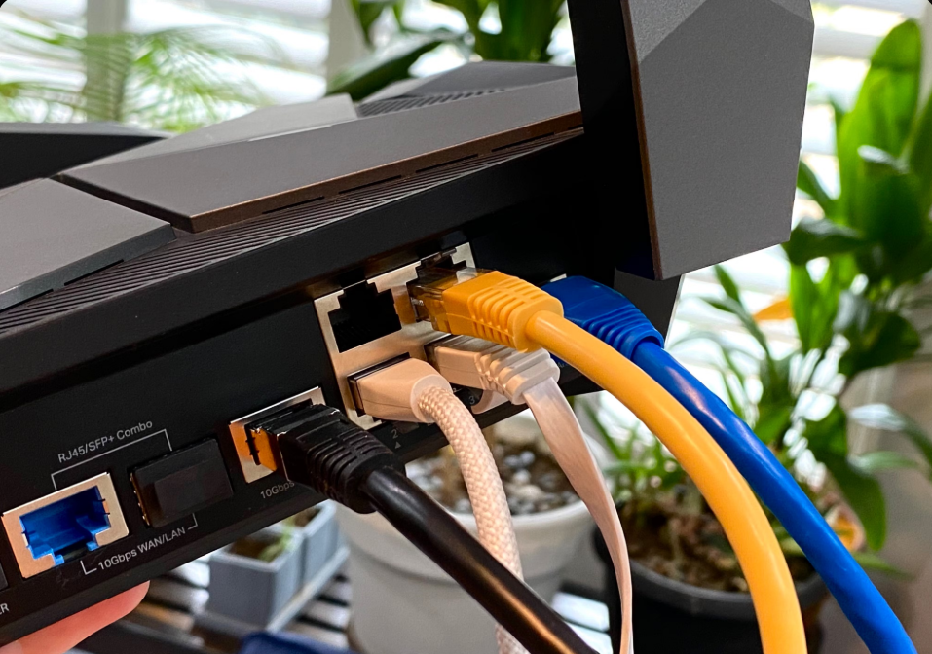

Here’s a clear example of a network cable in use:
![RJ45 Ethernet cable connected to a WiFi router]
What this is:
- Cable type: Ethernet patch cable (typically Cat5e or Cat6).
- Connector type: RJ-45 (8P8C) on both ends.
What it connects:
- One end is plugged into a LAN port on a WiFi router (the device that provides internet to your network).
- The other end (not visible in the close-up) would normally go to a device such as a PC, laptop, gaming console, smart TV, or network switch.
This setup is very common in homes, colleges, and small offices: the router gives a wired, stable connection to devices that need reliable bandwidth (for example, a desktop used for study, a console in a gaming zone, or a POS terminal in a café).
If you want, I can describe a second example (like a POS terminal or a network switch with multiple RJ-45 patch cables) in similar detail.

